National Convention of Workers (Online)
2nd October 2020

Resolution in Solidarity with the United Indefinite Strike in the Ordinance Factories by the Defense Sector Workers From 12th October 2020 against Corporatization/Privatisation

The National Convention of Workers being held on-line on 2nd October 2020 welcomes the brave and heroic initiative by the defense sector workers and all their unions/federations for united indefinite strike in Ordinance Factories from 12th October 2020 against the destructive decision of the Govt at the centre for corporatization of Ordinance Factories with the motive of ultimate privatization.

This decision of indefinite strike in Ordinance Factories jointly by all the Federations of defense sector workers, on the basis of overwhelming consent by almost entire workforce expressed through strike ballot, had been in continuation of the consistent opposition of the federations and workers to conspiratorial, anti-national move of the Govt for privatization of defense production network, manifested through various agitations by them including five days strike action in August, 2019 in the Ordinance Factories.

Despite tremendous pressure and provocation by the Govt and its machinery through unfair means to defeat the united struggle, the defense sector workers and their federations have been unitedly and successfully combating those pressures and provocations and carrying on intensive campaign and preparation for the strike, reflecting their firm resolve and determination to fight against the evil designs of the Govt.

The Joint Platform of Central Trade Unions and Sectoral Federations have all along been extending solidarity and support to defense sector workers’ united struggles including all strike actions.

This National Convention of Workers being held on 2nd October, Gandhi Jayanti Day, reiterates its commitment and solidarity to their forthcoming indefinite strike actions from 12th October 2020 against corporatization and privatization and calls upon all the unions and working people irrespective of affiliations to stage militant solidarity demonstrations and other form of united action in all workplaces, industrial centres etc in their support on 12th October 2020 and prepare for repeating similar solidarity action in succeeding weeks as the strike continues.

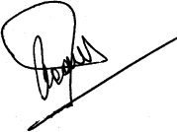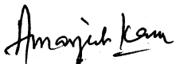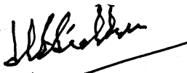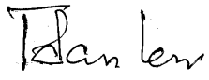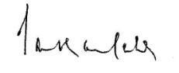
INTUC AITUC HMS CITU AIUTUC
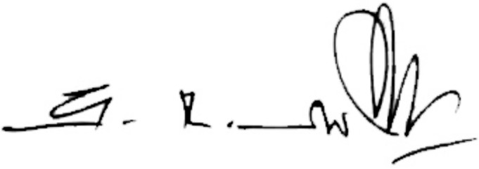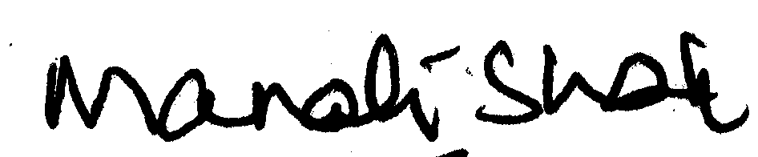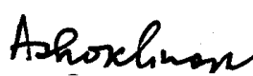
TUCC SEWA AICCTU LPF UTUC
And INDEPENDENT FEDERATIONS/ASSOCIATIONS
******

