National Convention of Workers (Online)
2nd October 2020

Resolution in Solidarity with Coal Workers’ Continuing Struggle against Govt’s Move for Private Commercial Mining and Privatisation

The National Convention of Workers being held on-line on 2nd October 2020 reiterates the whole hearted support to the coal workers united struggle against the destructive move of the Govt for private commercial mining of coal with the purpose of handing over the coal blocks for exploitation by private corporates, both foreign and domestic, completely deregulating trading of coal on the one hand and pave the way for gradual privatization of Coal India Ltd after weakening the same severely on the other. To facilitate this destructive process the Govt has allowed 100% FDI in coal mining against which the Coal workers staged militant strike on 24th September 2019.

Three days successful strike action by more than 5.30 lakh coal workers on 2-4 July 2020 in the midst of pandemic restriction braving all atrocities, prohibitory orders etc had been a great source of inspiration and confidence of the entire trade union movement. Following the strike action, the joint platform of coal federations have been undertaking series of agitational and campaign activities in the coal mine areas, preparing for further course of actions with the firm determination to fight and resist the move of privatization of coal sector through multi-pronged routes. Their joint movement and organizational initiatives have also extended among the people of the coal block areas targeted to be handed over to private agencies for commercial mining.

This National Convention of Workers notes that they observed 30th September, 2020 as Demands Day and have planned continuous actions from 1st October onwards and reiterates its support and solidarity with the coal workers’ struggles and all their agitational activities in preparation to further united struggles including strike actions determined to fight and resist the evil design of the Govt and calls upon all the constituents and the trade union movement in general to extend support to the continuing and determined anti-privatisation activities and initiatives of the united platform of coal workers’ unions/federations.

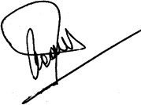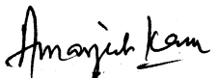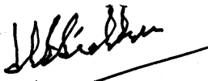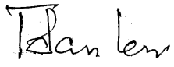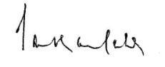
INTUC AITUC HMS CITU AIUTUC
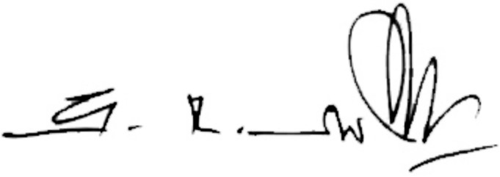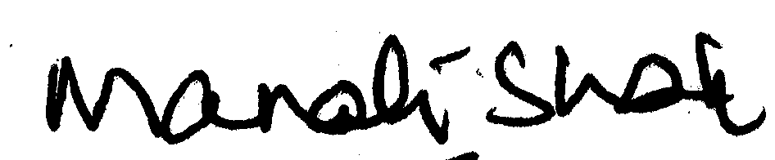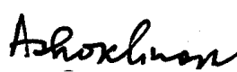
TUCC SEWA AICCTU LPF UTUC
And INDEPENDENT FEDERATIONS/ASSOCIATIONS
****

