National Convention of Workers (Online)
Gandhi Jayanti Day, 2nd October 2020

Declaration

This National Convention Of Workers, organised jointly by the Central Trade Unions and independent Federations/Associations, being held online for the first time due to the lockdown conditions that hinder physical gatherings, on 2nd October 2020, Gandhi Jayanti Day, strongly condemns the onslaught on the basic democratic and constitutional rights of the workers, farmers and common people of our country by Modi led BJP government at the Centre as well as by BJP State Governments.

The posture that the BJP government made in its first term (2014-19), of consulting stake-holders, has been totally thrown to the winds in its second term since 2019. While all indicators pointed to economy drastically slowing down due to lack of demand, the Government continued to steer their policies in the name of “ease of doing business” aggravating widespread impoverishment and deepening the crisis further. In the process, besides reducing corporate taxes, they have got the three anti-labour codes passed in Parliament most undemocratically, when the opposition parties were absent. These labour Codes are designed to impose conditions of virtual slavery on the workers, making formation of unions difficult and virtually taking away the right to strike, keeping large sections of unorganised sector workers, such as street vendors, domestic workers, mid-day meal workers, homebased workers, beedi workers, construction workers, rickshaw-pullers and other daily wagers etc. out of their ambit. In a similar way and in violation of all parliamentary and constitutional procedure, they have passed three farm bills and curbed the Essential Commodities Act, without legally guaranteeing minimum support price for farm produce, thus promoting corporate and contract farming, big food processing and retail monopolies, both foreign and domestic, and also endangering country’s food security. The Government has gone further: Without even placing the Electricity(Amendment) Bill,2020 in the Parliament, it has started privatising electricity distribution network ignoring opposing views by 12 Chief Ministers’, leaving the existing Employees at the mercy of the new franchise owners. Earlier, they resorted to merger of public sector banks without any effort at recovering huge NPA accounts, endangering common depositors money. Faulty formulation and policy on GST and the sliding economy has put Government finances in difficulty, consequently drying up States’ finances. RBI, LIC and various PSEs are being used as ATMs, only leading to further frenzy of privatisation of PSUs through auctions and 100% FDI: be it railway routes, railway stations, railway production units, airports, Port & Docks, profit making Government Departments, coal mines, cash rich PSEs like BPCL, 41 Ordnance Factories, BSNL (calling their 86,000 employees Deshdrohis), Air India, road transports and so on. All these destructive measures are being hastily pushed through when the country is reeling under Covid-19 pandemic. Even the so-called “Frontline Warriors” – Doctors, Nurses, Paramedical Staff, Sanitation Workers, Anganwadi, ASHA workers, who are being forced to carry out locality surveys at the risk to their own lives, were treated shabbily, not paying them promised monetary and insurance benefits! And the known crony capitalists are making headlines for increasing their market worth by crores of rupees every day of the pandemic!

The unplanned lockdown wrought untold miseries to crores of migrant workers, which make the stories of demonetisation pale by comparison. The period has been harder for women, who experienced increased harassment at workplaces, public places, as well as at home. The economy of the country came to a standstill, unemployment, especially of women, climbed to all time highest levels, while the GDP shrank as never before. The Government was never serious about their own advisories issued to the employers at the beginning of the lockdown - such as not to terminate workers, not to deduct wages for the lockdown period etc. They were tamely withdrawn when challenged by employers in the Supreme Court. But an opaque PMCARES Fund was floated where Corporates started contributing and Government employees were arm-twisted to contribute. Their DA is frozen. An old DO is resurrected that allows the Government to force an employee to retire prematurely. Thereafter, the Central Government has simply passed on the responsibility of handling pandemic situation on to the State Governments. The undermining of elected state governments, through money power, use of coercive targeting of political opponents through state agencies such as CBI, ED, NIA, Police is blatant, for all to see. The divisive machinations being played out, to tear up the secular fabric of our society, by implicating and accusing all intellectual opponents of CAA for conspiring and instigating North-East Delhi riots, and not even filing FIRs for hate speeches by BJP leaders by using Delhi Police has been condemned all around. The subversion of the Supreme Court is alarming. In this traumatic condition, New Education Policy has been introduced, which is wholesale privatisation of education, that will discriminate against poor people. In short, the Constitution is sidelined with impunity.

The situation is serious.

This national joint convention of trade unions strongly condemns these measures of the Modi led BJP government as being anti-worker, anti-peasant and anti-national.

This convention notes that various sections of workers and toiling people are tenaciously fighting these attacks on their hard won rights and benefits, on their lives and living conditions. The coal workers’ three days’ strike, the Ordnance Factories Workers strike, Railway Production Units workers demonstrations, BPCL workers two day strike, demonstrations and struggles of RTC workers, oil workers, steel workers, port workers, cement workers, scheme workers and workers and employees of various other sectors, ongoing agitations of the electricity workers and engineers in UP, who have launched big struggles including strikes against privatisation and on their other demands. The Convention stands firmly with the serious decision of the Ordnance Factories workers to go on indefinite strike from 12th October 2020 in defence of the country’s security. The Convention calls upon all the workers of the Country to hold militant demonstrations in support of the strike in all the workplaces on 12th October, 2020 and after every week thereafter, till the strike is settled honourably.

This convention extends full solidarity to the farmers who are demanding withdrawal of anti farmer agri-laws which have been passed without even allowing voting on them. This convention declares that the joint trade union movement would continue to support and express solidarity in all forms to their struggle at the national level as well as in any part of the country. The workers stand in firm solidarity with the farmers.

While appreciating the huge participation of workers in all the joint trade union protest programmes taken up by the joint trade union platform during the lockdown period, despite the immense difficulties imposed due to the lockdown, this convention underlines the necessity to further intensify the struggle. The Modi government at the centre has no qualms in sacrificing the interests of workers, farmers and all toiling and common people of the country for the benefit of the Corporates.
Despite the continuous demand by not only the entire trade union movement, but also by eminent economists, to ensure cash transfer to put money into the hands of the people that would not only provide some succour to them but revive the country’s sliding economy, the BJP government is not ready to do so. Despite our godowns overflowing with food grains, the BJP government is not ready to provide free ration to the needy.

This convention strongly asserts that this situation calls for higher forms of united resistance struggles in the form of defiance and non-cooperation by the entire working class. It calls for solidarity of all sections of working people, workers, peasants and agricultural workers.

This convention calls upon the entire working class of our country to prepare for a country wide general strike on the following demands:

- Cash transfer of Rs 7500 per month for all non income tax paying families
- 10 kg free ration per person per month to all needy
- Expansion of MGNREGA to provide 200 days’ work in a year in rural areas at enhanced wages; extension of employment guarantee to urban areas
- Withdraw all anti farmer laws and anti worker labour codes
- Stop privatisation of public sector including the financial sector and stop corporatisation of Govt run manufacturing and service entities like Railways, Ordinance Factories, Ports etc.
- Withdraw the draconian circular on forced premature retirement of Government & PSU Employees
- Provide Pension to all, scrap NPS and restore earlier Pension, improve EPS-95

This convention calls upon the working class to organise joint state/ district/ industry/sectoral level conventions, physically wherever possible, online otherwise, before the end of October 2020; to conduct an extensive campaign on the adverse impact of the labour codes on the workers down to the grass roots level up to mid November and for the one day country wide general strike on 26th November, 2020. Let it be known that this One Day Strike is in preparation for more intense, more tenacious and longer struggles that lie ahead.

The Convention calls upon all the working people, whether unionised or not, affiliated or independent, whether from organised sector or unorganised sector, to intensify the united struggle against the anti-people, anti-worker, anti-farmer and anti-national policies of the Govt and make the call for countrywide general strike on 26th November, 2020 a total success.

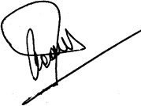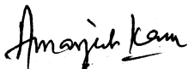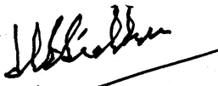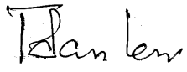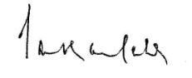
INTUC AITUC HMS CITU AIUTUC
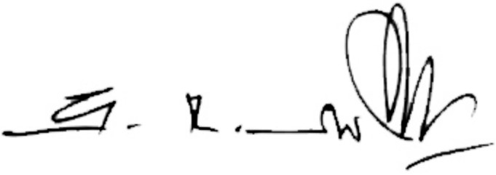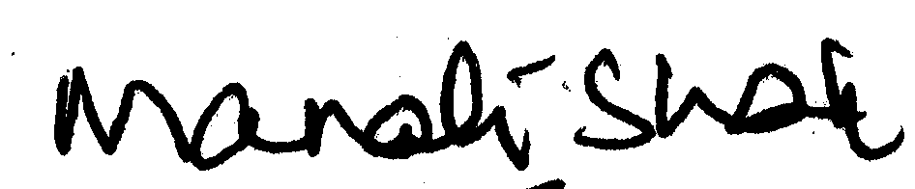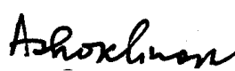
TUCC SEWA AICCTU LPF UTUC
And INDEPENDENT FEDERATIONS/ASSOCIATIONS
****

