Solidarity With The Ongoing Anti-Privatisation Struggles of Electricity Employees of UP
The National Convention of Workers, being held on 2nd October 2020, congratulates the Electricity Workers and Engineers of the entire state of UP for their ongoing massive militant joint struggles under the joint banner of Vidyut Karmachari Sanjukta Sangarash Samity, UP (VKSSS, UP) composed of 18 organisatios of Trade Unions and Associations of Engineers resolutely opposing the anti-people move of the UP Government to privatise the electricity distribution of the state PSU – UPVVNL. The current move of the UP Government is to immediately privatise the UPVVNL, a huge revenue earning zone consisting of, inter alia, Varanasi, Allahabad, Gorakhpur, Sonbhadra, Sidhartha Nagar. This is being done even without placing the Electricity (Amendment) Bill, 2020 in the Parliament, which has these anti-people provisions of privatization. The National Co-ordination Committee of Electricity Employees and Engineers (NCCOEEE) has consistently opposed this policy and so have the Chief Ministers of 12 States. The experiment of privatization has failed so far, yet the Central Government is pushing it, dangling a carrot of permitting increased limit of borrowing to those States that carry out these ‘Power Reforms’.
The VKSSS, UP demonstrated excellent sense of responsibility and flexibility in that, prior to launching direct action, they organized massive propaganda and campaign. After Duty Hours massive demonstration of employees throughout the state for a long period of seven weeks as a precursor also to provide opportunity to the Government to take note of the strong opposition of the employees as a whole against privatization and rescind the move. Shockingly the UP Government responded by resorting to repression. Clearly the ongoing direct action by UP electricity employees has arisen due to the repressive act of the authoritarian Government of UP.
On 28th September 2020 after duty hours the employees organized peaceful rallies in the state capital and all the districts and the UP Government resorted to large-scale arrest. In response the electricity employees have launched ‘Three Hours’ Work Boycott’ throughout the state since 29th September2020
Following the call by NCCOEEE, the VKSSS, UP has declared that from 5th October, 2020 the employees all over the state of UP shall launch Full Work Boycott indefinitely. The National Convention of Workers extends full support to the ongoing anti-privatisation struggle of UP electricity employees and warns the UP Government that total trade union movement stands in active solidarity with the struggle.
The Convention appeals to the entire trade union movement of the country in general and the trade unions and associations in power sector in particular to take immediate preparations to launch solidarity action in support of heroic fight of the UP electricity employees. Anti-privatisation struggle in the country today is obviously the most priority task of the working class.
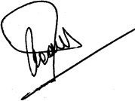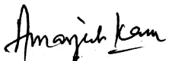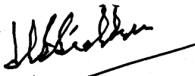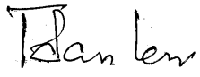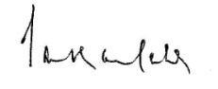
INTUC AITUC HMS CITU AIUTUC
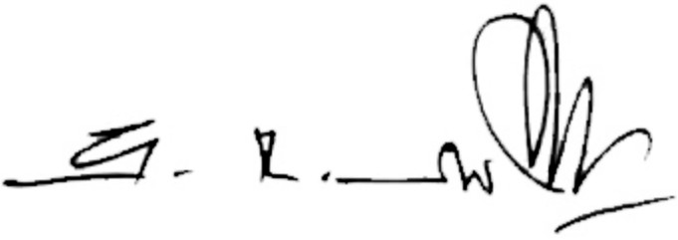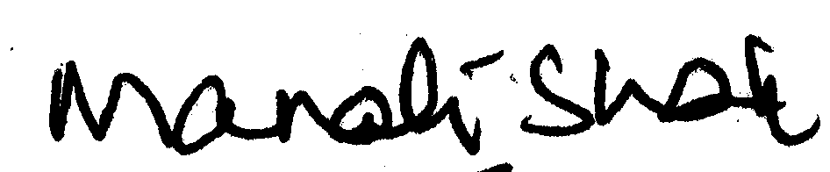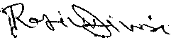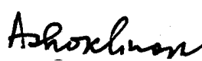
TUCC SEWA AICCTU LPF UTUC
And INDEPENDENT FEDERATIONS/ASSOCIATIONS

